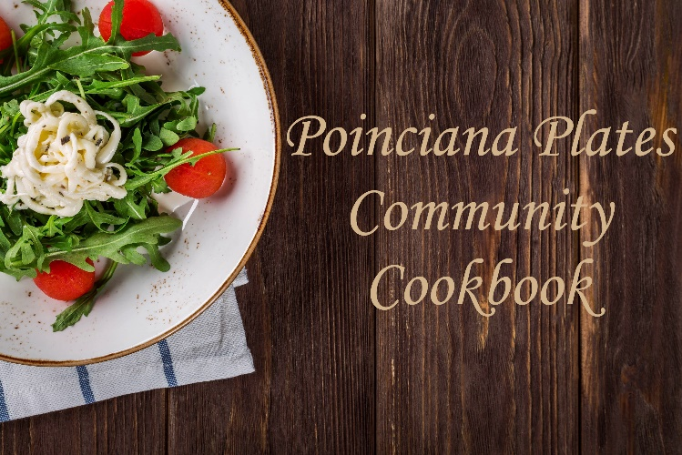

NAME OF DISH
Your Name

INGREDIENTS

DIRECTIONS

Serves-

